

ST10448699

Nape Makgopa

WEDE5020

–

POE

2024

POE

NAPE TIRO FEZILE MAKGOPA

[COMPANY NAME] | [Company address]

Contents

Part 1 3

Website choice 3

Description Of The Organization 3

Reason For Choosing The Organization 3

Assets 4

Information About The Organization 4

Navigation To Use My Website 5

Images Used On My Website 5

Website Page And Content: 5

About 6

Part 2 8

Improvements to Part 1 8

Bibliography 9

# Part 1

## Website choice

**Organization Name**: Little Angels Home

**Type:** Non-Profit Organization (NPO)

**Purpose:** Supporting Orphaned and Abandoned Children

**Website Aim:** To provide information, raise awareness, and generate support for the care and well-being of orphaned and abandoned children.

### Description Of The Organization

Little Angels Home is a compassionate and pragmatic NGO for the care of abandoned children in order to provide them with a home. Sadly, hundreds of thousands of children around the globe become orphans because of diseases, wars, and poverty, and they do not have a chance to receive the necessary education or to be provided with the means and love they need. These children are then taken to Little Angels Home where they are provided with a home and a chance to be whatever they want to be.

The organization was established to meet the needs of these children in their early years to ensure that every child is given an opportunity to live a happy and fulfilling life. For extended popularity and to make approachable the potential donors and volunteers, Little Angels Home is planning to build up a simple website.

### Reason For Choosing The Organization

Little Angels Home shares my dedication to helping children in need. They provide vital care, education, and support, which perfectly matches my commitment to social responsibility and community aid. I chose Little Angels Home because I believe that as people who show our support, we can make a big difference by helping them assist more children, upgrade their facilities, and expand more programs.

The website will contain information about the organization’s goals and objectives, as well as the available services such as education, health, nutrition, and recreation. It will also include the stories of the children and their experience, their stories, and the story of Little Angels Home with the stories that will encourage other people to support the center.

A significant component of the website is a donation and sponsorship section whereby users will be able to make one-off or regular donations and receive timely information on how the funds are being utilized. The site will also feature a way for people to sponsor children’s education or medical needs and a volunteer corner for people who want to dedicate their time and effort.

In addition to the fundraising and volunteers, the website will also act as an advocacy tool where new articles, blog posts, and research articles as well as the latest news about the welfare of children in different parts of the world will be posted. The major goal of Little Angels Home is to raise awareness of the plight of the orphans and abandoned children and advocate for policies that will enhance the welfare of these kids.

Concisely, the Little Angels Home will be an active informational, educational, and advocacy website. Offering informative information, helping with donations and sponsorships, and promoting volunteerism, Little Angels Home aims to have a positive effect on the lives of the children.

## Assets

### Information About The Organization

The NPO started in 2005 with only 2 children but placed 3 more children within the first year of operations due to the big need for residential care facilities in the area. Little Angels moved around quite a bit in the first few years, but eventually found the perfect home in Bridgewater, Somerset West. Today Little Angels is home to 17 children, between the ages of 0 - 18 years.

All the children at Little Angels require 24-hour, highly specialized care and support as a result of their disabilities. The majority of the children suffer from multiple medical conditions such as Cerebral Palsy, Epilepsy, Microcephaly, and Hydrocephaly. The children require assistive devices such as wheelchairs and buggies. Many of our children have PEG Tubes for feeding as the cannot take in food orally. Read more about the types of disabilities below.

We are driven by the overwhelming need for similar residential care facilities in our community, breaking down stigmas and stereotypes regarding disabilities and increasing awareness for those living with disabilities. We would like Little Angels to continue thriving, by sticking to our core values; compassion, dignity, competence and dedication and be an example for our fellow NPO’s.

### Navigation To Use My Website

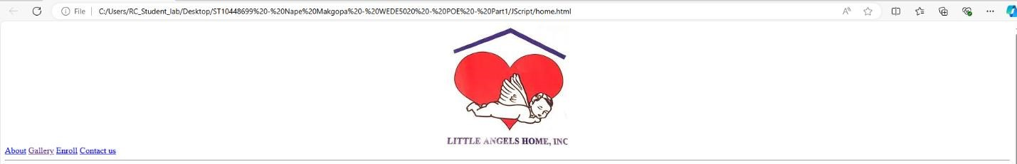

### Images Used On My Website

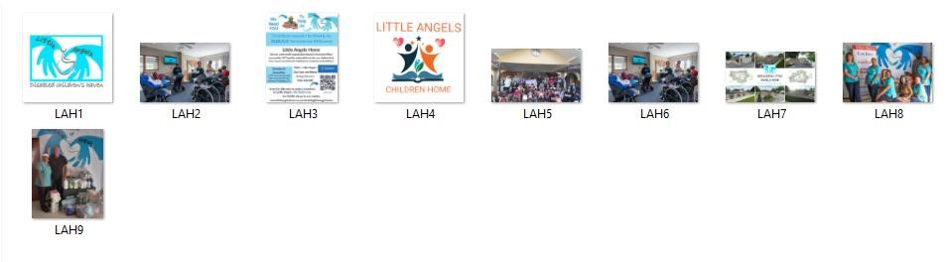

### Website Page And Content:

* Home
* About
* Gallery
* Enroll
* Contact us

#### Home

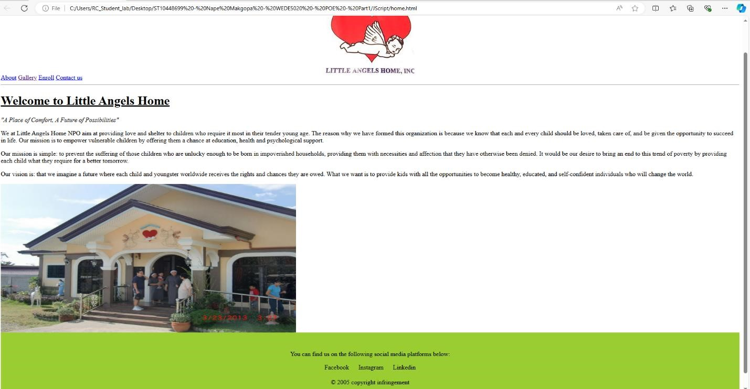

### About

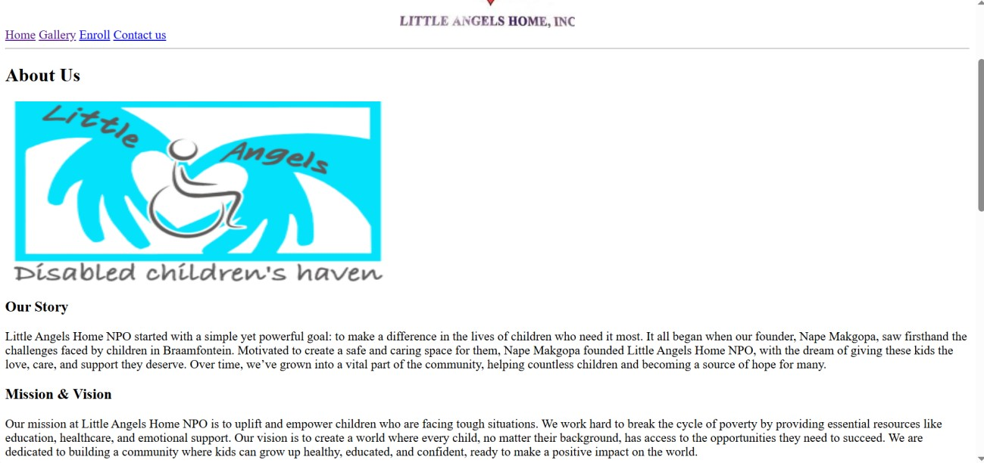

#### Gallery

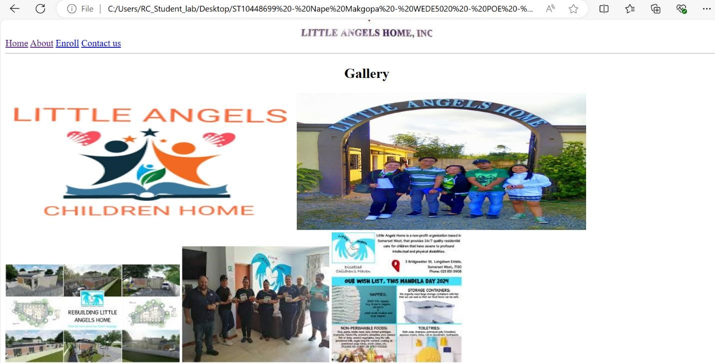

#### Enroll

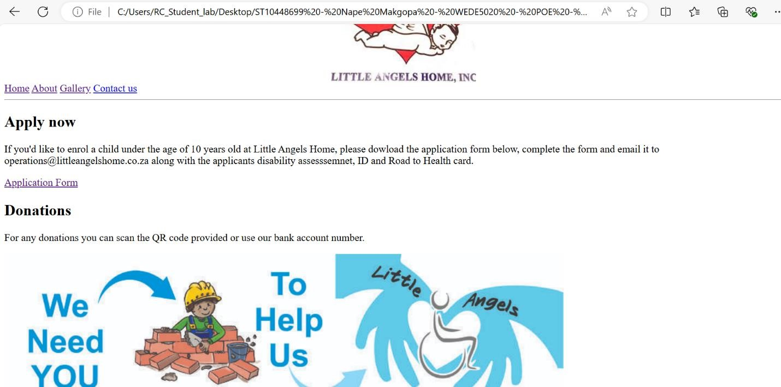

#### Contact Us

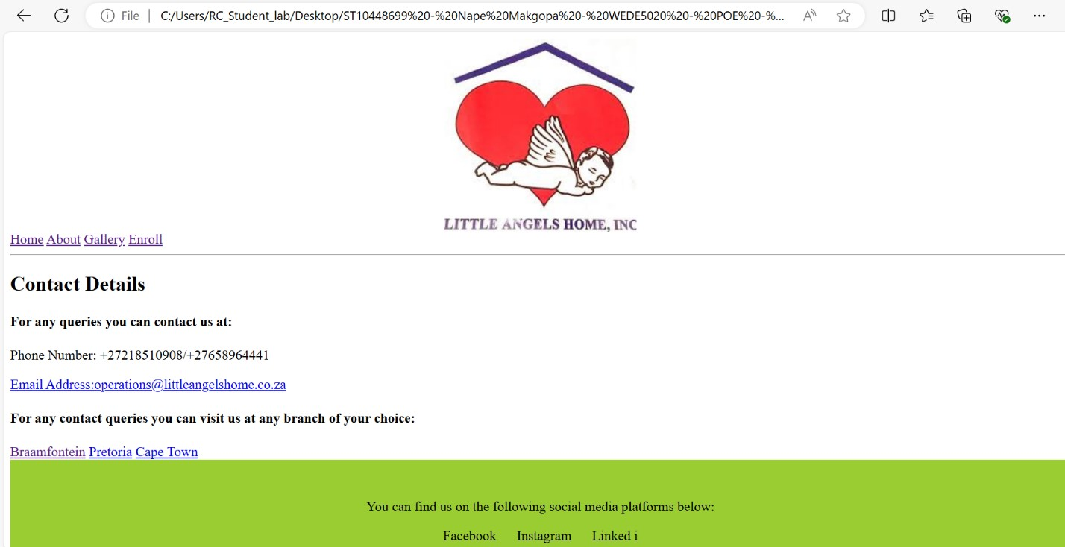

# Part 2

## Improvements to Part 1

I have added headers on every page of my website.  
Missed a closing tag </hr> at line 23 on the About page, also added.  
Added color on each page.  
Updated table of contents.

## Bibliography

Jager, T. d., 2005. *Mapping Disability: Stellenbosch and Helderberg.* [Online] Available at: https://disabilitynetworkmapping.weebly.com [Accessed 25 August 2024].

mieke@captivating.web.za, 2005. *Little Angels Home.* [Online] Available at: littleangelshome.co.za [Accessed 20 August 2024].